Connor Bush

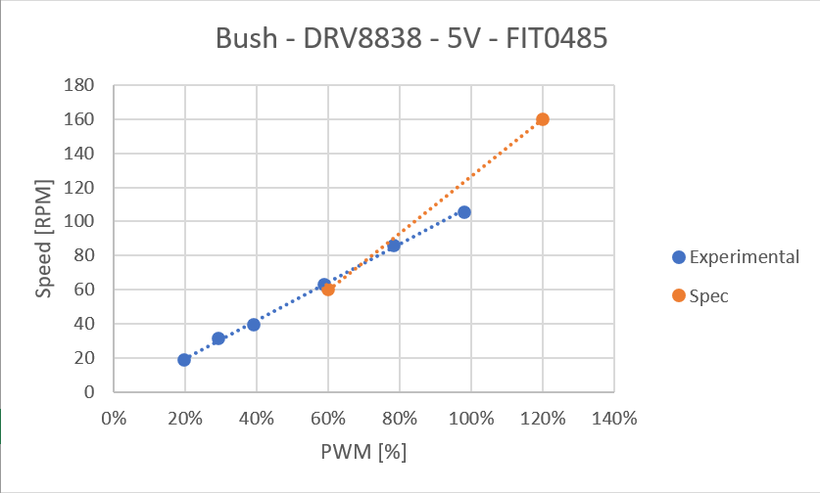

Joseph Heald

